IMG_256

### **[点微]短信接口**

阿里大于短信接口

**阿里云短信服务接口设置教程**

**第一步：打开阿里云短信服务**[https://dysms.console.aliyun.com/dysms.htm](https://dysms.console.aliyun.com/dysms.htm" \t "http://www.tomwx.cn/_blank)

[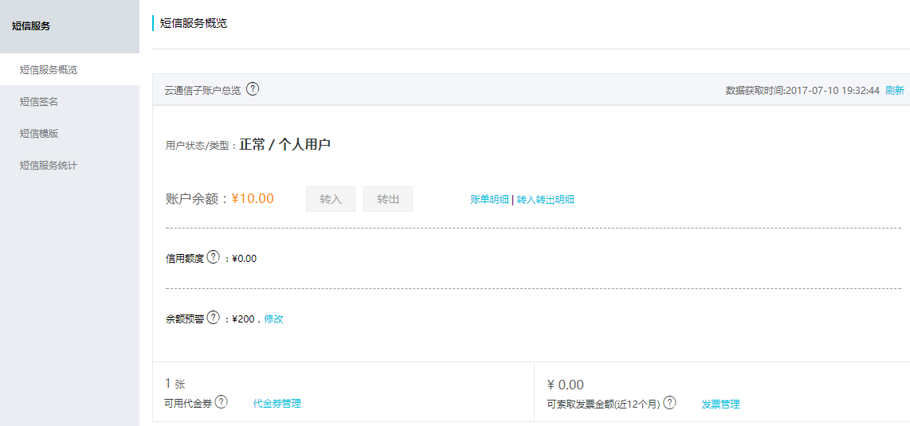](http://www.tomwx.cn/source/plugin/tom_editor/editor/attached/image/20170710/20170710113410_94203.png)

**第二步：添加短信签名**

[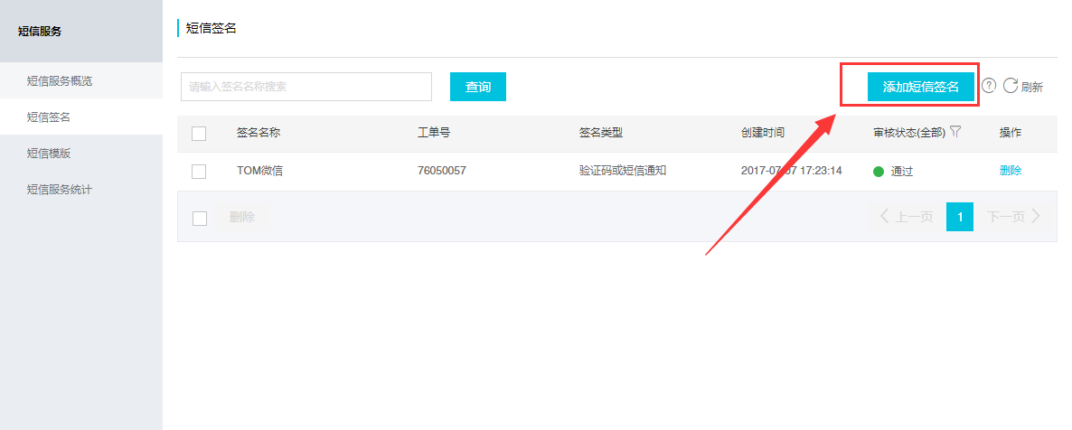](http://www.tomwx.cn/source/plugin/tom_editor/editor/attached/image/20170710/20170710113445_41065.png)

**第三步：添加短信模板**

[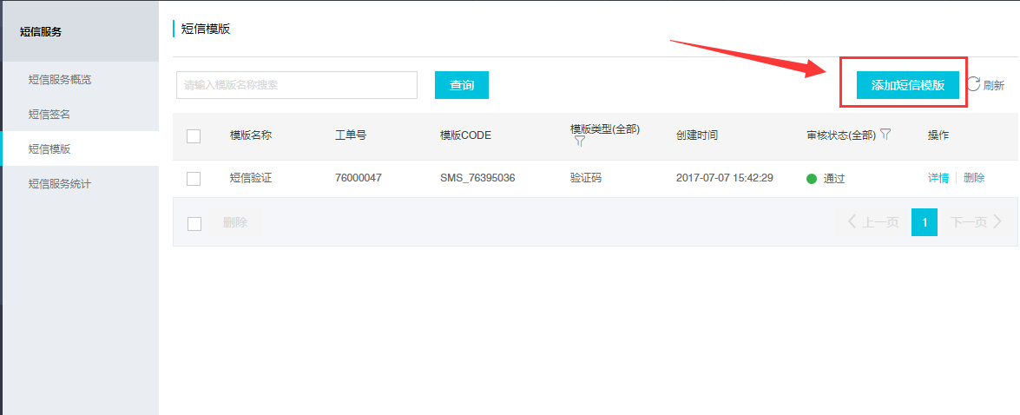](http://www.tomwx.cn/source/plugin/tom_editor/editor/attached/image/20170710/20170710113541_21752.png)

[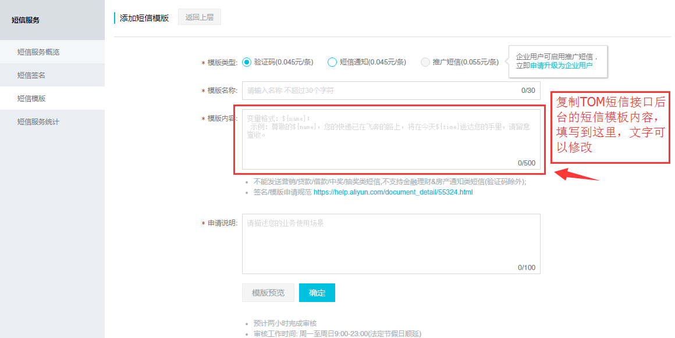](http://www.tomwx.cn/source/plugin/tom_editor/editor/attached/image/20170710/20170710113556_72707.png)

**第四步：创建应用填写获取appKey 和 appSercet 填写到插件后台**

[https://ak-console.aliyun.com/#/accesskey](https://ak-console.aliyun.com/" \l "/accesskey" \t "http://www.tomwx.cn/_blank)

[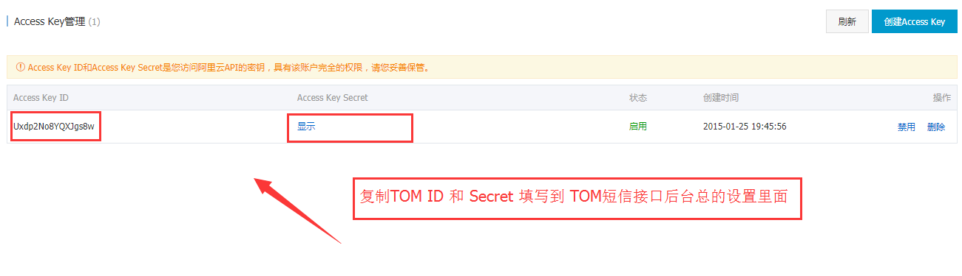](http://www.tomwx.cn/source/plugin/tom_editor/editor/attached/image/20170710/20170710113808_68818.png)

**第五步：获取模板ID和短信签名，填写到插件后台**

[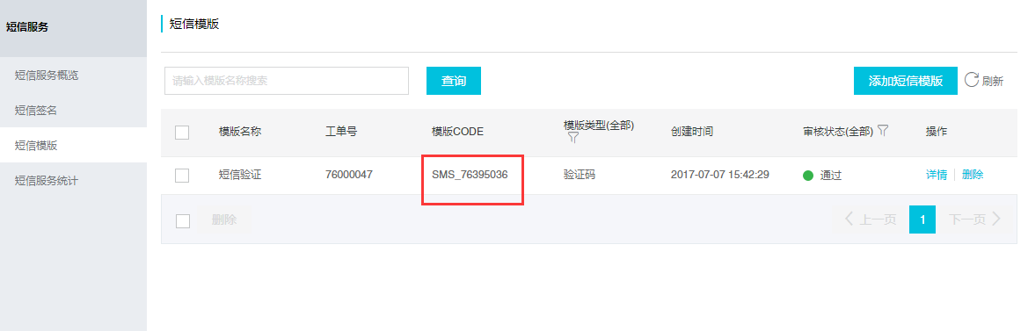](http://www.tomwx.cn/source/plugin/tom_editor/editor/attached/image/20170710/20170710114224_79029.png)

[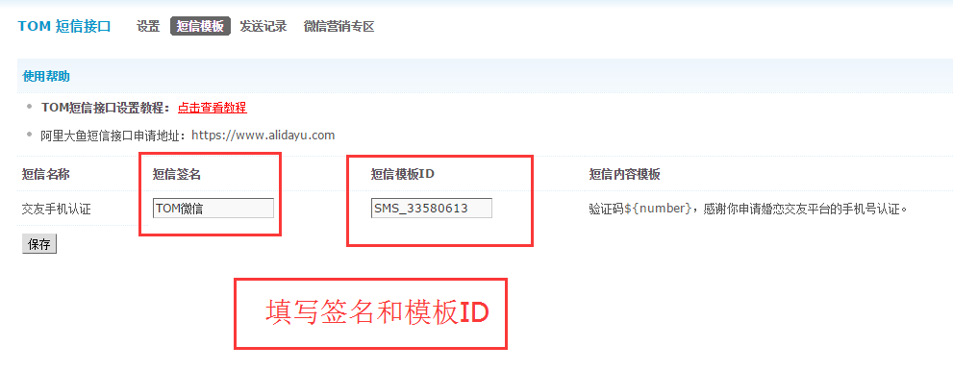](http://www.tomwx.cn/source/plugin/tom_editor/editor/attached/image/20170223/20170223040506_59570.png)

**第六步：OK了**